GRADE 7 ACCELERATED · UNIT 1 · LESSON 3  Solving Two-Step Equations  Worksheet 7A.01.03 | Name_________________________  Date__________________________  Period________________________

1. Match each property of equality to the example that shows it. Write the letter of the example on the line.
Every example below starts from 5 = 3 + 2.
Property of Equality | Letter
Symmetric Property of Equality
Addition Property of Equality
Subtraction Property of Equality
Multiplication Property of Equality
Division Property of Equality

A. | 5 × 4 = (3 + 2) × 4
B. | 3 + 2 = 5
C. | 5 ÷ 4 = (3 + 2) ÷ 4
D. | 5 + 4 = 3 + 2 + 4
E. | 5 − 4 = 3 + 2 − 4

Use the equation 2 + 3n = 11 for questions 2 through 5.
2. Complete the sentence to describe the equation.
The variable n is first being __________________ by 3, and then 2 is being __________________ to this product. The value of the expression 2 + 3n is __________________ to 11.

3. Describe the operation that isolates 3n on the left side.

4. Describe the operation that isolates n on the left side.

5. Now solve 2 + 3n = 11. Then check your solution by substitution.

For questions 6 through 11, solve the equation and check your solution by substitution.
6. 2x − 5 = 11

 | 7. | 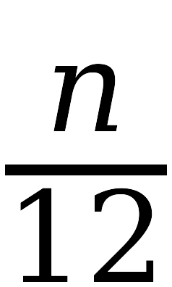 | − 3 = 7

8. 6y + 5 = 29

9. 9a + 7 = 88

 | 10. |  | − 8 = 4

 | 11. | −8 + |  | = 10

